Name of View: Uses Model View

Primary Presentation:

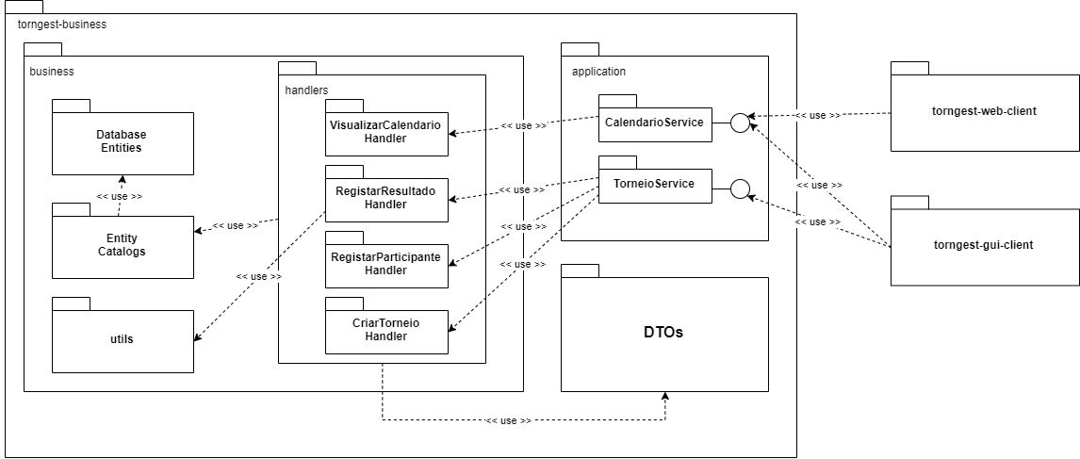

Element catalog:

* torngest-business – this module contains all the classes related to business logic handling give the input from the available clients. It implements 4 main use cases:
  + Create tournament
  + Register tournament participant
  + Register tournament scores
  + View participant schedule
* business – this module contains the main classes for all the logic handling necessary
* Database Entities – this package contains all the entities that define the table within the WildFly database, i.e. their columns and respective values. These classes also have a set of JPQL queries which can be used to add and retrieve data from the database.
* Entity Catalogs – this package contains all the entity catalogs following the information expert design patter, each catalog will be responsible for accessing a certain entity from the database given any restrictions necessary. Database access will be done in the form of TypedQueries, granting safe access by disabling SQL injections.
* handlers – this package contains the 4 handlers which implement each one of the use cases defined. The handlers will do most of the logic processing and value checking before getting data from or sending data to the database through the catalogs.
* utils – this package contains a simple helper class which calculates the score of a given tournament, it is only used by the RegistaResultado Handler.
* Application – this module contains the main services accessed by both the GUI and Web clients. These services will expose all the functions implemented in the system via a remote interface which will be injected to both clients.